**USER INTERFACE SCREEN:**

**.1 Logo Screen:**

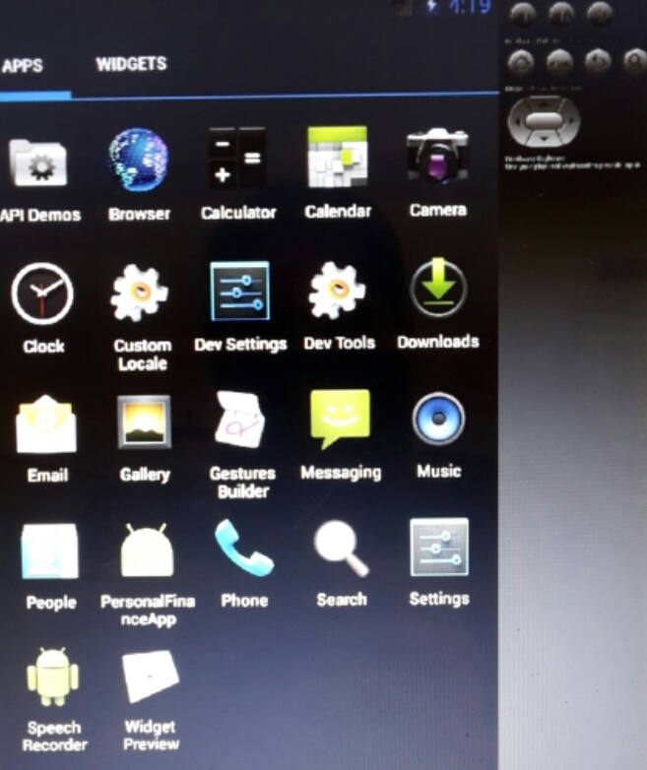

**.2 Welcome Screen:**



**3 User Registration Screen:**

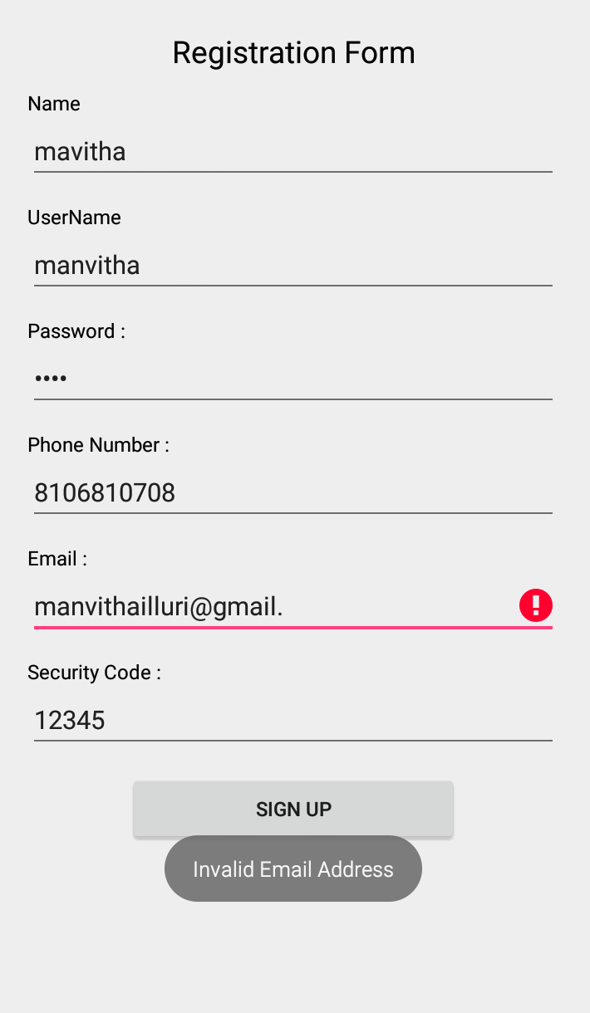

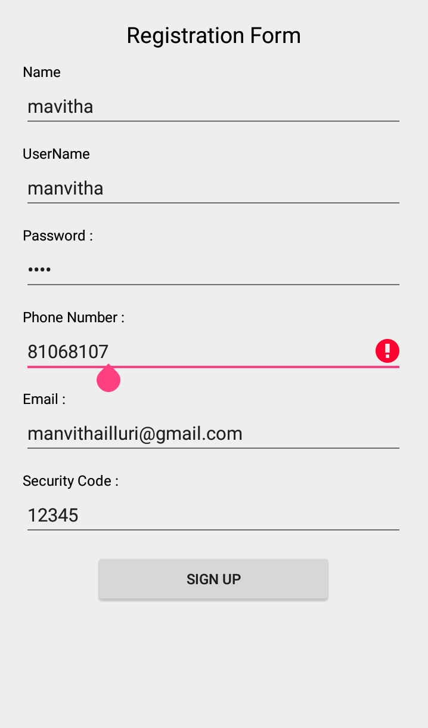

**4 User Login Screen:**

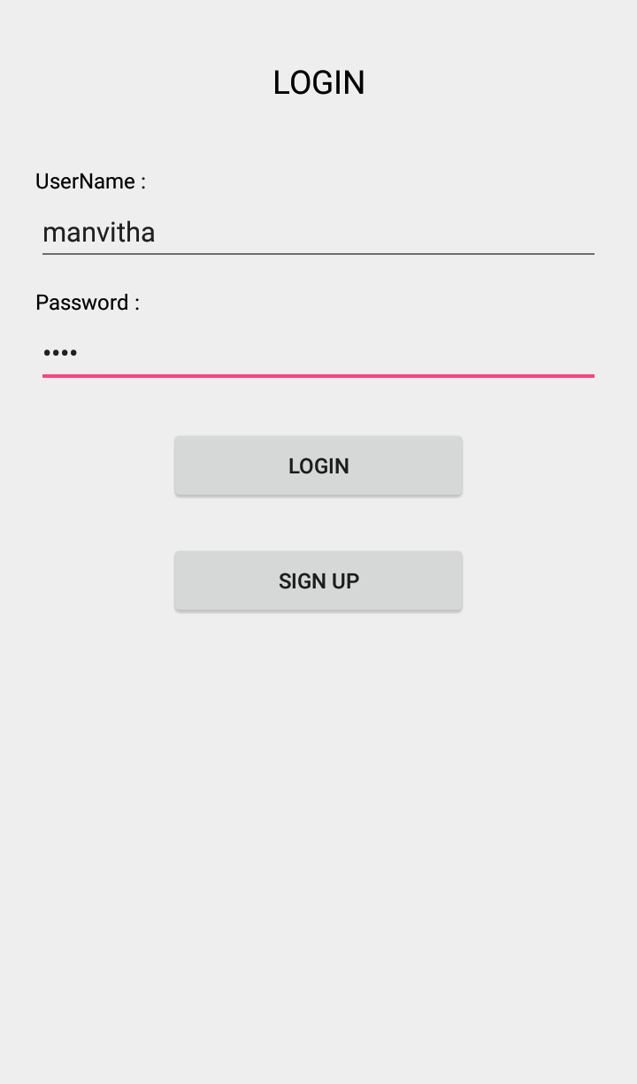

**5 User screen:**

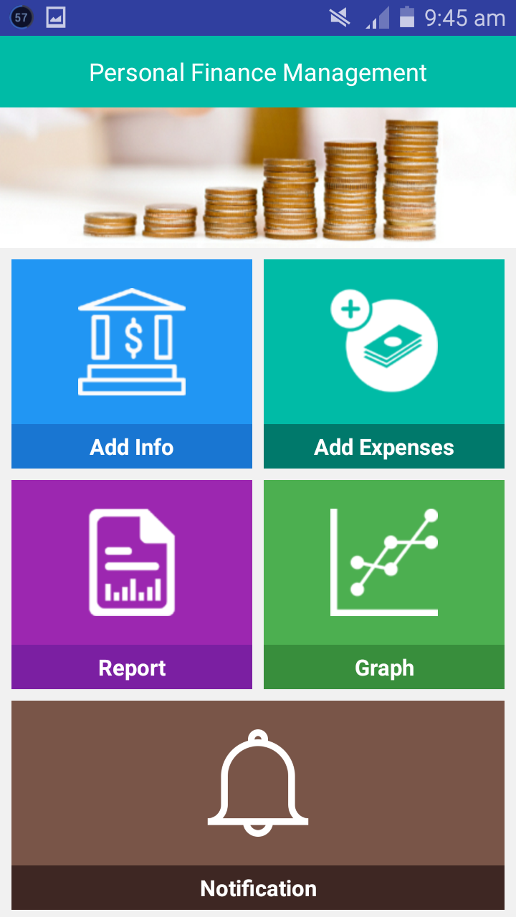

**.6 User Add info Screen:**

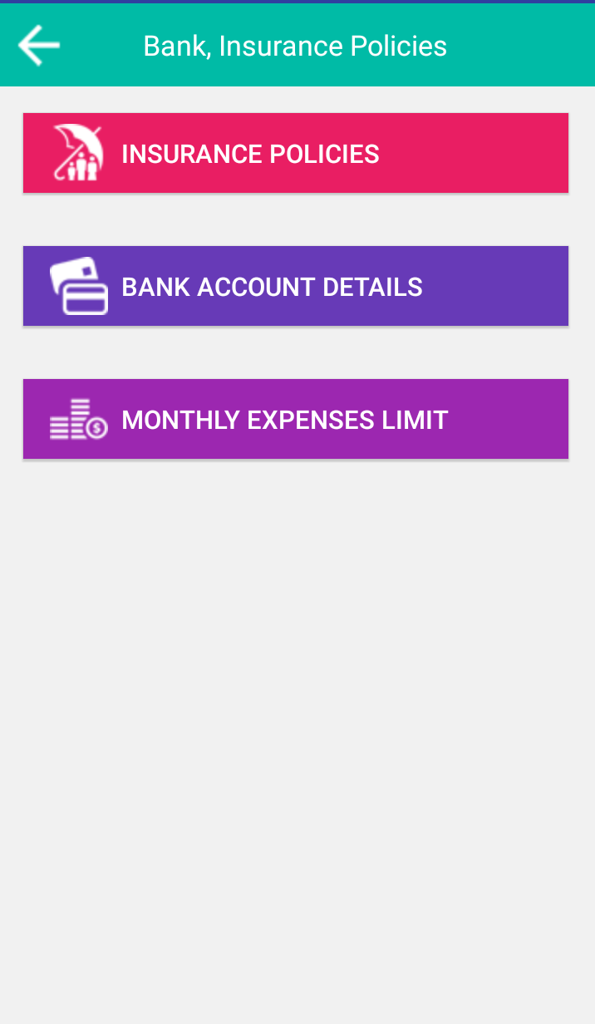

**.6.1 Insurance Policy Details Screen:**

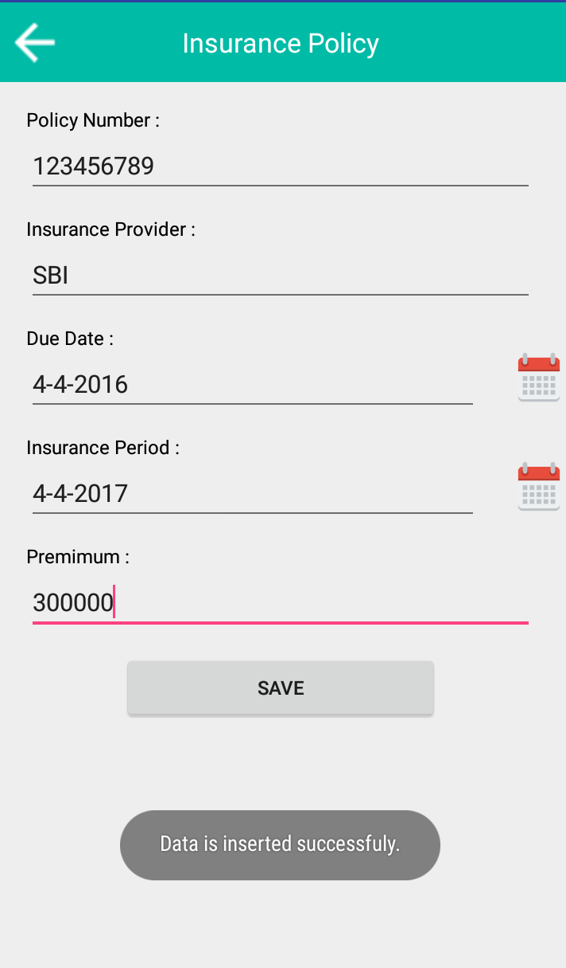

**6.2 BankDetails Screen:**

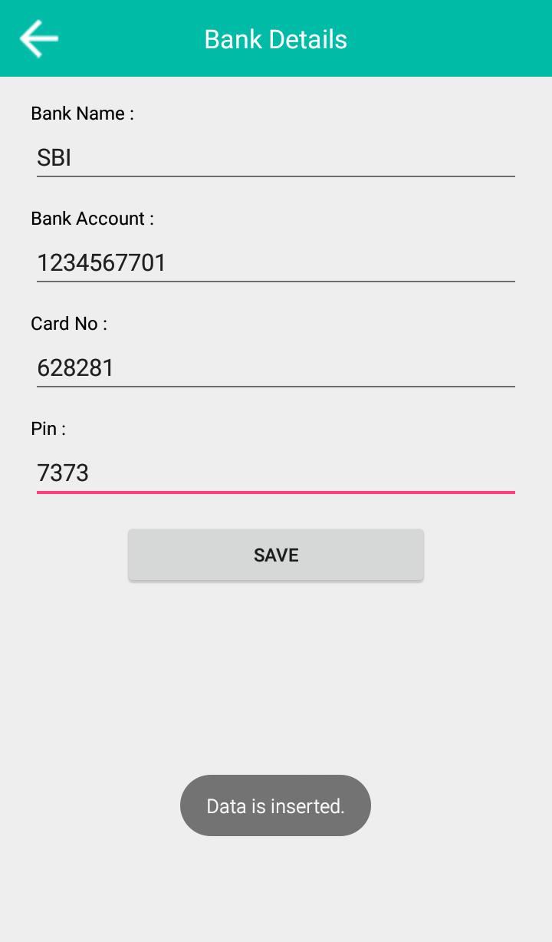

**.6.3 Maximumlimit Expenses Screen:**

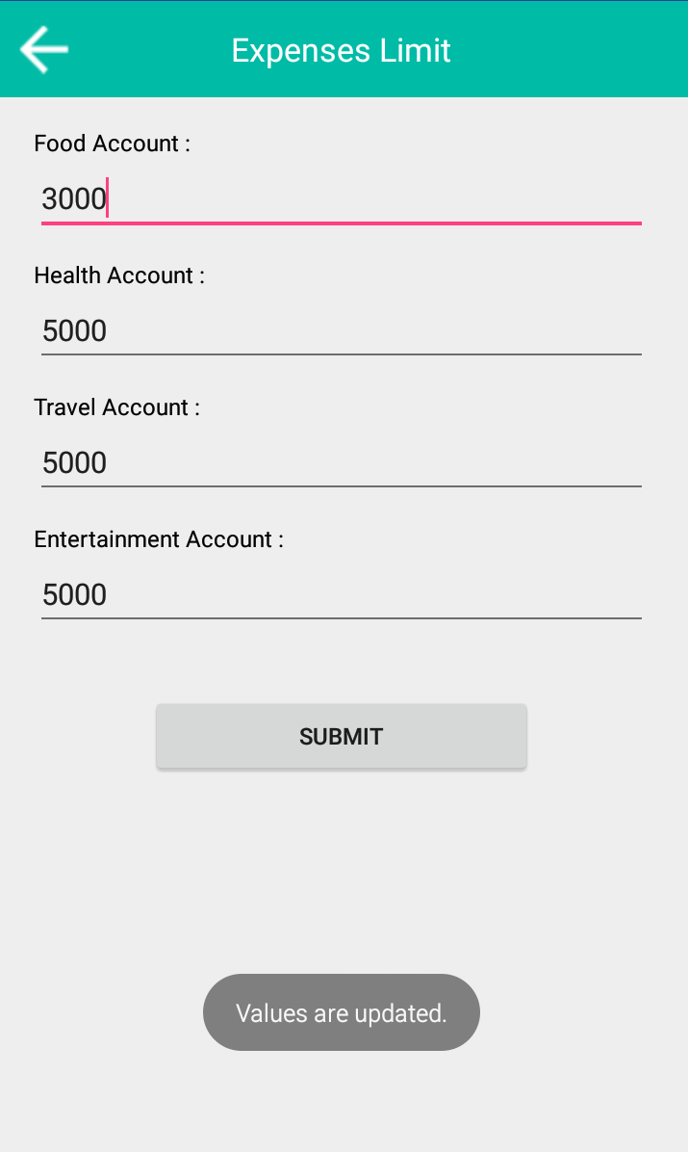

**7 Add expenses screen:**

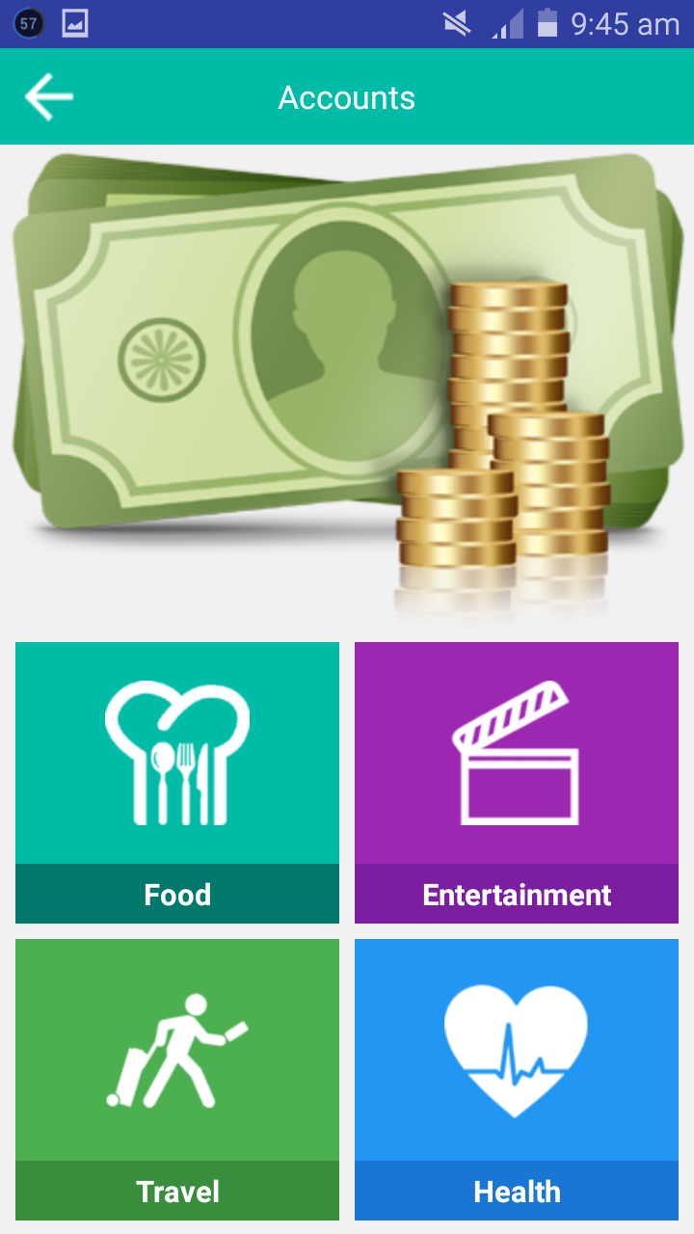

**7.1 Food Expenses Screen:**

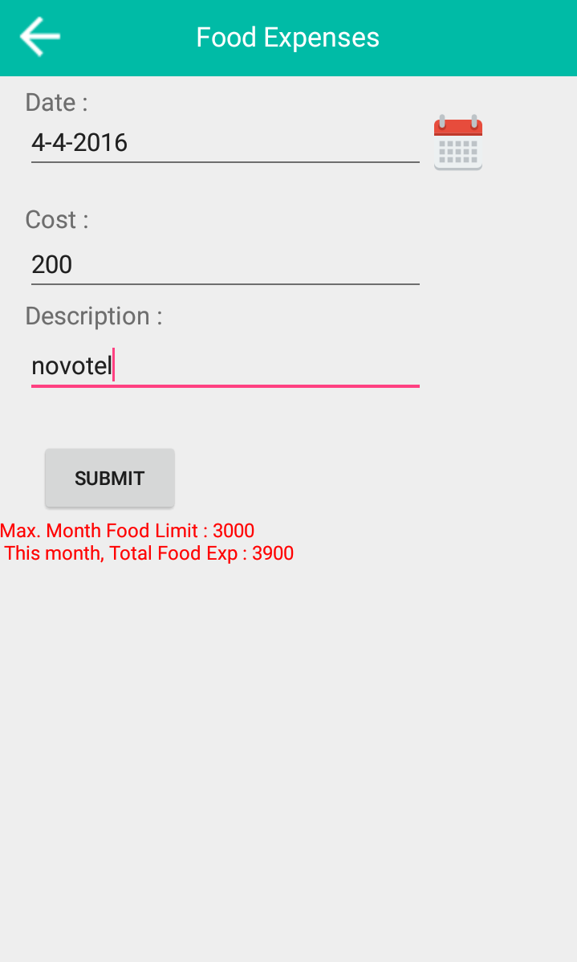

**7.2 Entertainment Expenses Screen:**

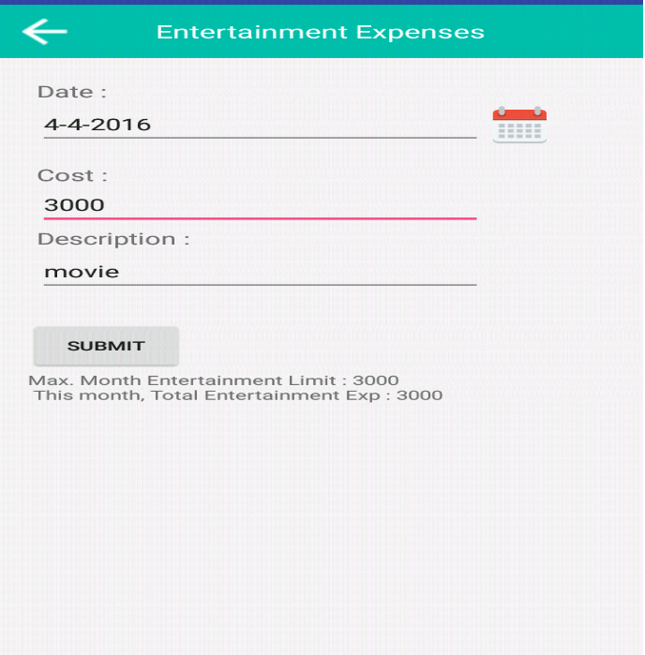

**5.7.3 Travel Expenses Screen:**

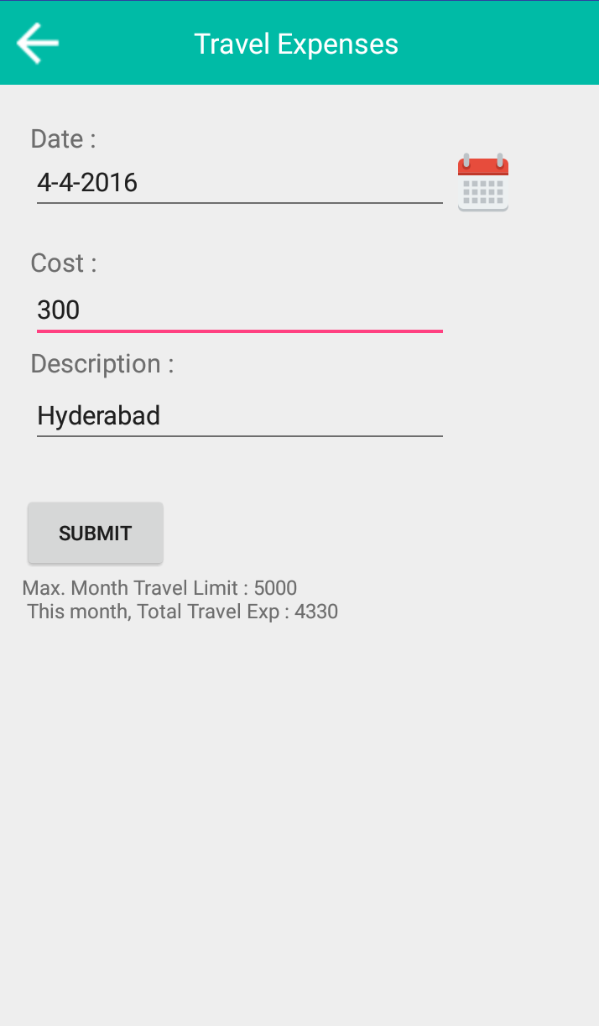

**7.4 Health Expenses:**

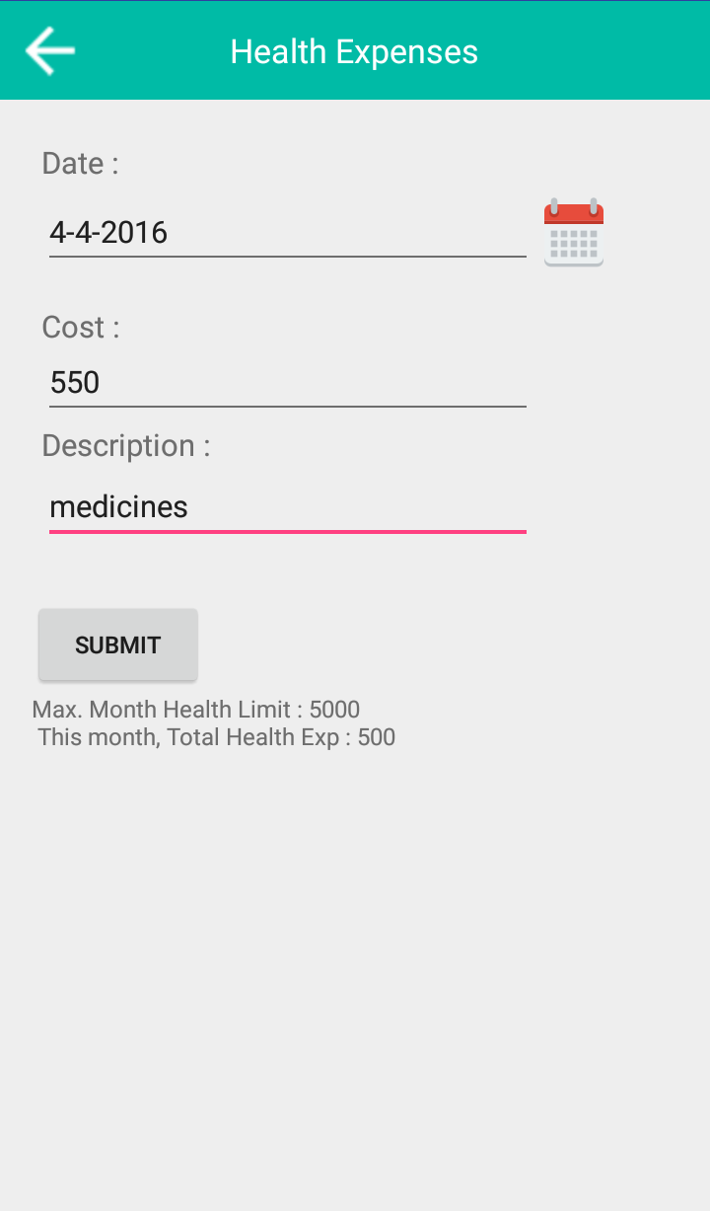

**.8 Reports Screen**

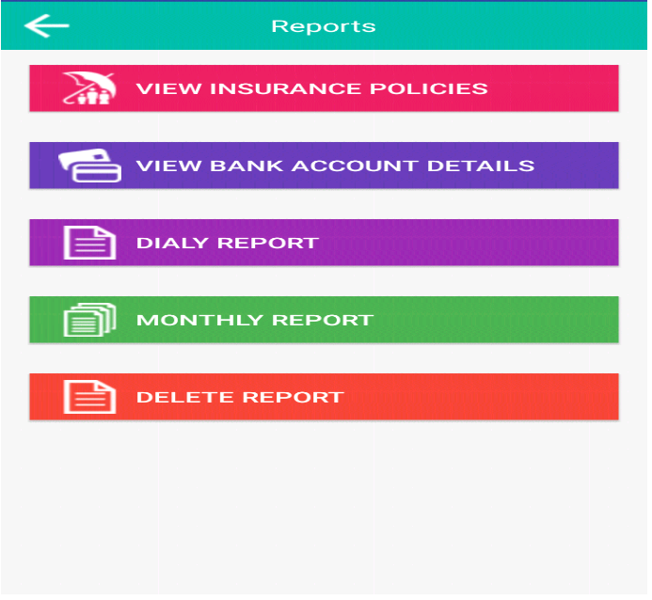

**8.1 Insurance Policies Screen:**

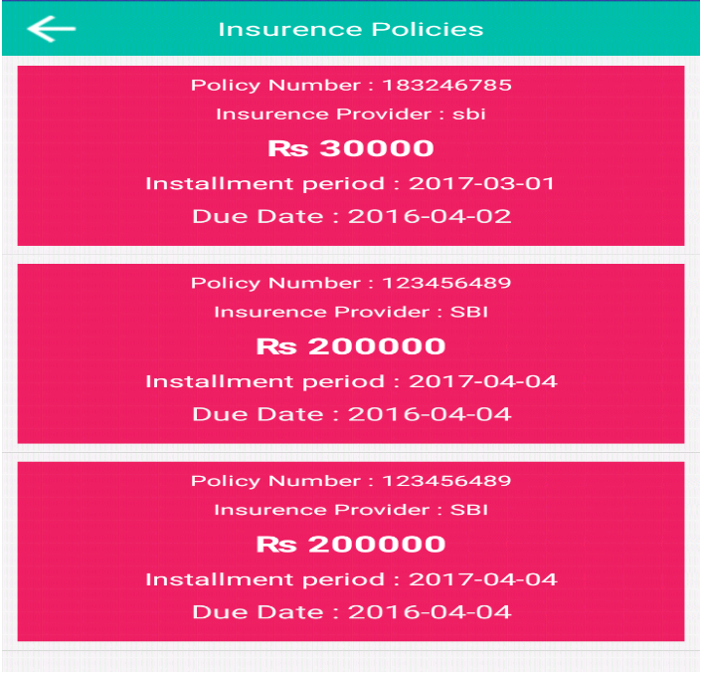

**5.8.2 Daily Reports Screen:**

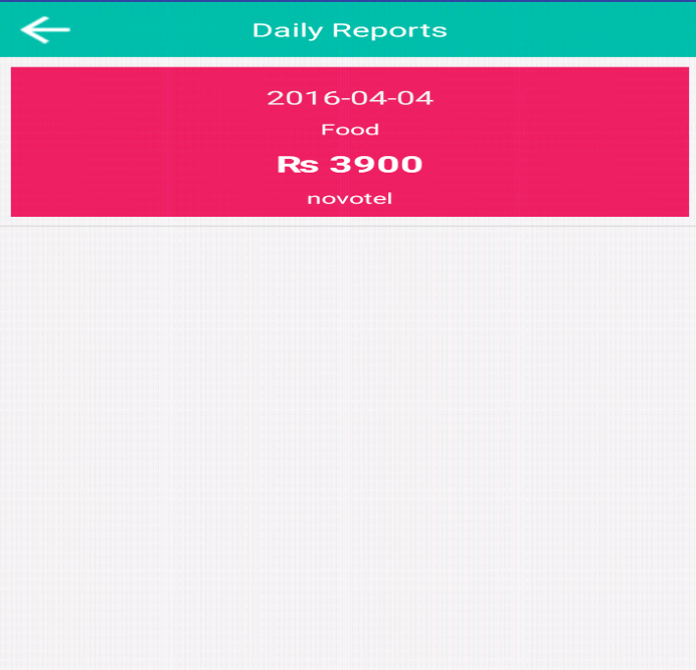

**8.3 Monthly Reports Screen:**

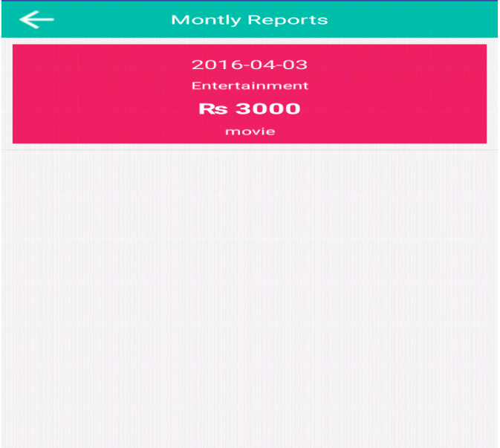

**.8.4 BankAccount Details Screen:**

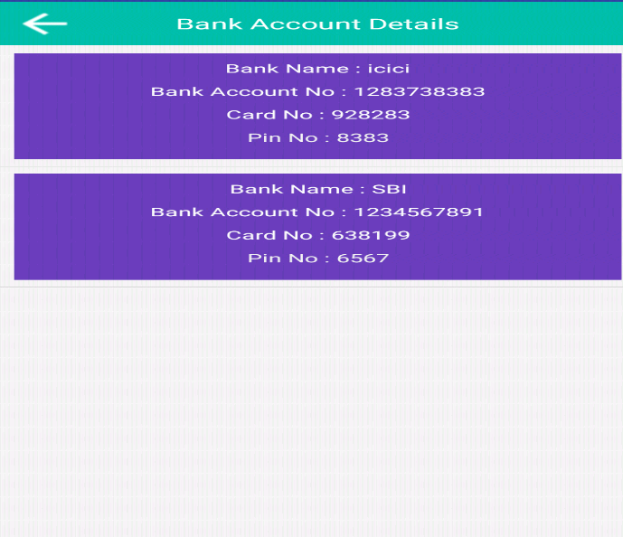

**8.5 Delete Reports Screen:**

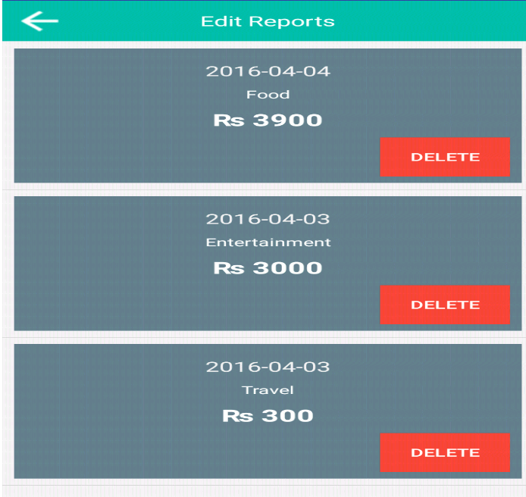

**.9 Daily Graphical Report Screen :**

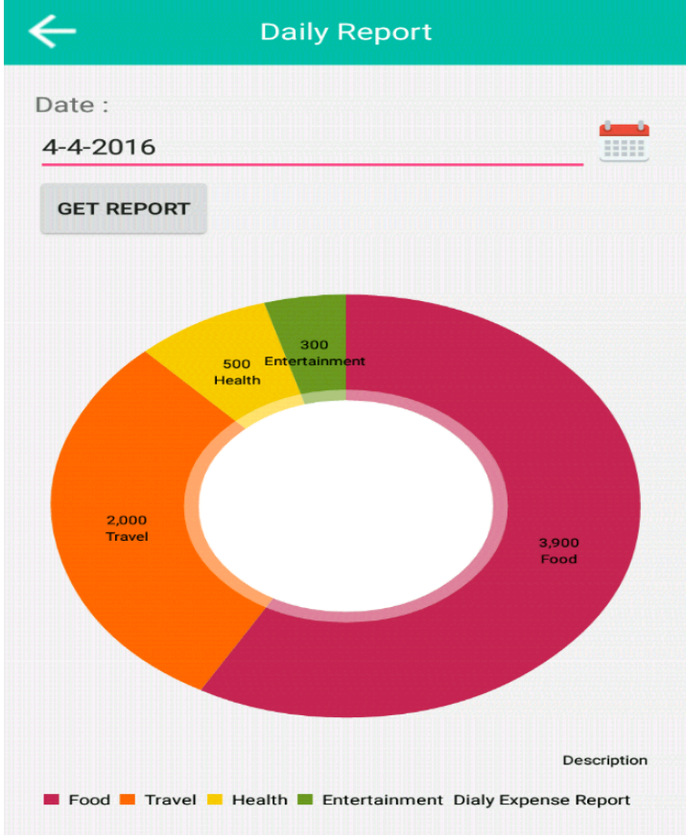

**10 Monthly Graphical report Screen:**

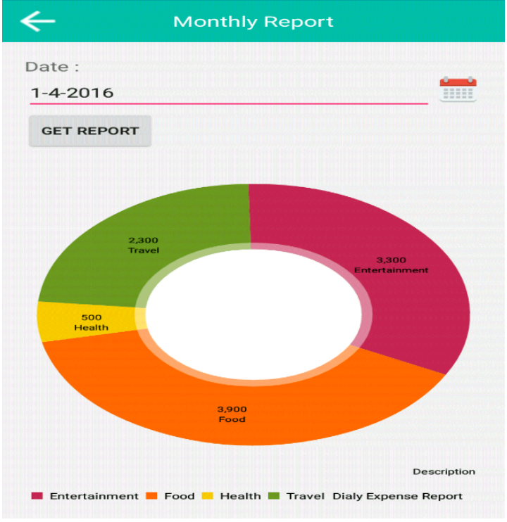

**10.1**

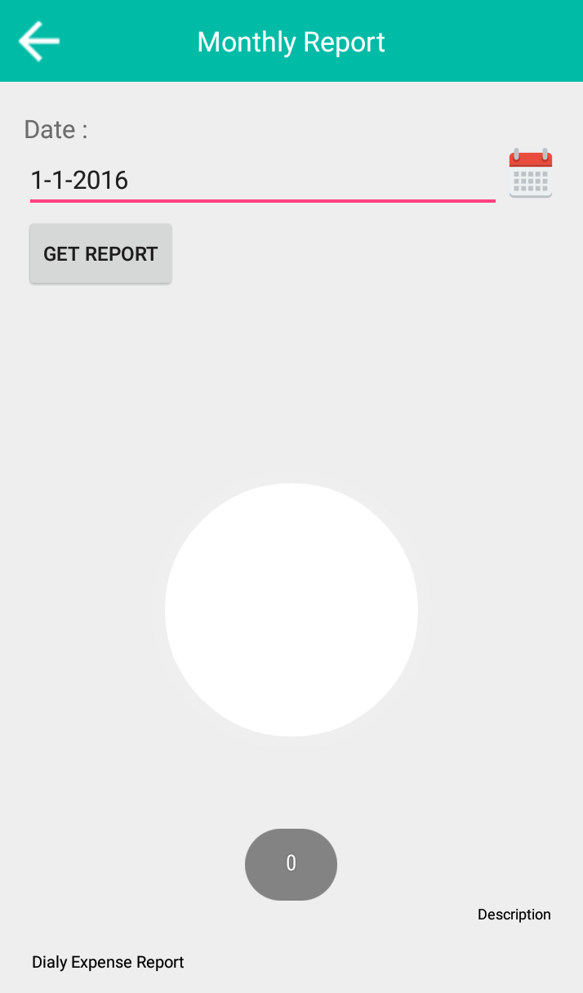

**11 Notification Screen:**

